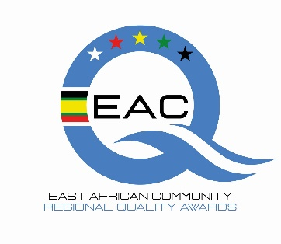
East African Community (EAC) Regional Quality Awards

Abridged Roadmap

 | Milestone | Target Date
 | Launch of National-Level Competitions | April 2026
 | Deadline for Submission of Entries at National Level | 30th June 2026
 | Selection of National Winners | 30th August 2026
 | National Winners to be Submitted as Nominees for Regional Competition | 30th August 2026
 | Selection of Regional Winners | 30th September 2026
 | Regional Awards Ceremony - Kigali, Rwanda | October 2026

